Friday 17th March 2017

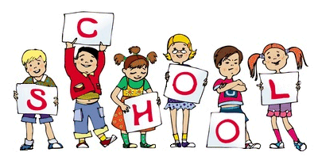

MCj04126840000[1]

MCj04126840000[1]

General Reminders

* Please make sure that your child’s P.E kit is in school on a daily basis.
* Miss Gallimore & Miss Hawcroft will be available to speak to every morning on the door and if you require more time an appointment can be made.
* Please label your child’s jumper with their name. If there is no name on a jumper it is almost impossible to find.

Welcome to the Key Stage One newsletter! It’s been an exciting week at Pike Fold as we have had a delivery of eggs which will hatch this week. All the children are really excited to see the chicks and will have the opportunity to care for them. All classes have been doing work linked to the chicks – Year 1 are keeping a video diary & Year 2 are looking at animals and habitats in their Science lessons. Keep an eye out on the website for any news! **We are holding an Easter egg raffle –** Year 6 children will be visiting all the classrooms in the afternoons so the children have chance to buy a raffle ticket. Tickets are 50p.

**Dates to remember:** Friday 24th March – Year 1 trip to Eureka

**Community Links:** to ensure the environment around the school is the best for our children, please can we make sure that our litter is placed in the bins provided. Please can we make sure that if we are a dog owner, the dogs are not fouling on foot paths around our school. Thank you for your support.

Staff

Miss Hawcroft – KS1 Manager – Deputy Head

1P – Miss Shore, Miss Goodall, Ms Bowker

1F – Miss Hancock, Mrs Stevenson, Miss Burgess

2P – Miss Garner, Mrs Howarth

2F – Miss Trotter, Mrs Thompson, Mrs Robinson

Homework Marks This Week

Spelling Test:

Homework Complete:

Homework this week.

Spellings – Spellings handed out today to be tested on Thursday for Year 1. Year 2 spellings are sent home today to be tested on Wednesday.

Homework – **Year 2**: Highlighted and dated pages to be completed from the comprehension books and maths workbooks each week. **Year 1**: complete page 21 of their maths workbook.

Reading – Please make sure that your reading books are returned by Wednesday in order to be changed.

Websites – Check out our new website! Lots of resources and information!

**www.pikefold.manchester.sch.uk**

Stars of the Week

