Friday 24th March

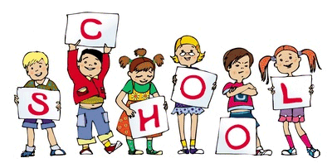

MCj04126840000[1]

MCj04126840000[1]

We have been enjoying watching our chicks grow this week, we have talked about what they need to thrive, we have described their features and done observational drawings and created play dough figures. It was sad to see them go, but they have now outgrown their home and need more space. We hope you have enjoyed watching their progress on our website blog- we would love to hear any feedback in the comments section!

Thank to everyone who attended our Mothers day parent craft session- we hoped you enjoyed working with your child and speaking to your child’s key worker.

If you have any queries about your child’s learning staff are available on the door every day or a longer appointment can be made if needed. Please remember to email us any parent observations you do at home with your child, they are so helpful for your child’s learning journey!

Notice Board/Dates for your Diary

TOPIC –**Food and Growth.**

* We have an EYFS Parents Email which you are welcome to send any comments or enquiries to: [eyfsparents@pikefold.manchester.sch.uk](mailto:eyfsparents@pikefold.manchester.sch.uk)
* Family Engagement Officer Miss Gallimore contact number: **0161 795 4614.**
* Blackpool Zoo trip: Thursday 30th March. Children to wear school uniform and a waterproof coat. If your child normally has a pack lunch please bring in a disposable plastic bag (including a disposable drink) clearly labelled with your child’s name. If your child has a school dinner they will be provided with a packed lunch from school.
* School closes for Easter at 2pm on Friday 31st March.
* Return to school for the Summer term on Tuesday 18th April.

At Home

Ideas to help at home – Number of the week is 5.

**Reception homework:** Page 23/ 24 of the maths work book.

Phonics group spellings week: Group A & B week 8 and Group C week 3.

To encourage your child to be more independent please ask them to put on and zip up their own coat.

Child Voice: The chicks.

*Dominica: “Its fluffy!”*

*Alfie. N: “The girls are brown and the boys are yellow”.*

*Josh. L: “ They have wings, we don’t have wings!”*

*Freya: “They are hopping, they are trying to fly!”*

General Reminders

* Please check out our website blog and leave any comments!: [www.pikefold.manchester.sch.uk](http://www.pikefold.manchester.sch.uk) and click on the EYFS page.
* Please can we ask children not to bring toys in from home as we can’t be responsible for them.