Friday 8th September

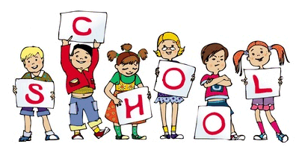

MCj04126840000[1]

MCj04126840000[1]

Notice Board

**We now have a new on-site after school childcare facility. It is available to all children and is ran by ‘Bear Club’ which is part of the Bear Necessities Day Nursery.** A member of the ‘Bear Club’ team will be in the school dining room after 3.30pm for all after school childcare enquiries.

TOPIC – **People who help us**

Our main aim during the next few weeks is to ensure that your child feels safe, comfortable and confident in and around school. As the children are settling into their new class we will be teaching them how to use each area of the classroom to forward their learning and learn the routines of the day.

VOTE FOR US!

All children in Reception will have access to Forest School one afternoon a fortnight this term! To help fund Forest School we are asking parents and family members to vote for us at Tesco stores in Blackley and Cheetham Hill- all you need to do is ask for blue counters at the checkout which you put in a clear plastic container at the front of the store- Pike Fold Forest School is one of 3 community projects which are in chance of winning so please vote for us! Voting takes place between now and the end of October.

Ideas to help at Home

Share books regularly with your child

Have a look at the school web-site and talk about what we have been doing in school.

Help them practise their tricky words – the, to, I, no, go

Encourage your child to practise their scissor skills

Encourage your child to practise writing their name

Useful website –[www.ictgames.com/resources.html](http://www.ictgames.com/resources.html)

We hope you have all had an absolutely wonderful summer-despite the weather! Welcome to the first edition of the EYFS (Early years foundation stage) newsletter! Please look out for these newsletters in your child’s book bags or schoolbags as they are a valuable source of information and will keep you up to date with your child’s education and important diary dates. On behalf of all the staff at Pike Fold EYFS, we would like to say a huge ‘Welcome’ to you and your child as you begin your learning journey with us in the Foundation Stage Unit.

In these newsletters you will be able to find out any important information that you will need to know for the following week. We also update our web-site page and blog and you can find important information on here. We regularly update the blog with photos of any exciting activities we have been doing in school so please take a look!

Through the newsletter we will keep you updated about what the topic for this half term is and what we have been learning about to enable you to give as much support at home as you possibly can. If you have any questions at all, please feel free to ask any of the EYFS team. Here is to another fantastic year!

General Reminders

* Please make sure that your child’s P.E kit is in school on a daily basis. (Reception Only)
* Please ensure your child has a spare change of clothes in school.
* Please remember to bring in a waterproof coat and wellies (these can stay at school) everyday