Friday 16th June

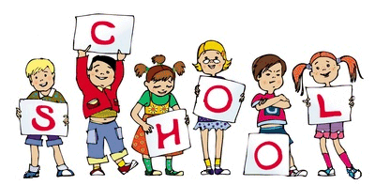

MCj04126840000[1]

MCj04126840000[1]

This week we have continued our new topic ‘Journeys and Holidays’ and the children have enjoyed playing in our ice-cream shop and beach role play. We had a fantastic time during out parent craft workshops and the children enjoyed making their cards, key rings and coasters and we have now added photographs to our EYFS blog on the website if you would like to take a look! We welcome your questions, suggestions or positive feedback. On Wednesday the children loved taking part in our ‘Healthy Living day’ they all joined in the work out and picked food for a healthy and unhealthy lunchbox. A reminder to please make sure your child has a hat or sun cream in school and sun cream is applied before coming to school in the morning. The children must be able to apply their sun cream themselves. Water is available all day. Next week we will be starting transition with Reception going to Year 1 and Nursery going into Reception on Monday and Tuesday morning. If you have any questions please ask a member of staff. Thank you for your continued support.

Notice Board/Dates for your Diary

TOPIC – **‘Journeys and Holidays’**

* Please contact us through the EYFS parent email for if you have any questions; [EYFSparents@pikefold.manchester.sch.uk](mailto:EYFSparents@pikefold.manchester.sch.uk) and I will get back to you ASAP.
* Our Chair of Governors is Eddie Roberts and he is available to contact by email – chair@pikefold.manchester.sch.uk
* Feedback from EYFS parents is always very positive. If you would like to share this with OFSTED inspectors please find the **parent view** link on our school website.
* EYFS Trip to Manchester Airport on Wednesday 28th June
* EYFS Trip to Manchester Airport on Thursday 29th June

Child Voice

**Leighton:** “All aboard the train if you want to come on holiday to Spain”

**Nicole:** “We’re doing lots of exercise aren’t we, it’s good for us”

**Jake:** “There’s lots of sugar in coke, it’s unhealthy and it rots your teeth”

**Joshua:** “There’s not sugar in crisps but there’s fat in them”

**Ibrahim:** “I like bananas at snack time, they’re good for me!”

General Reminders

* Please remember to bring in a waterproof coat, wellies and a sunhat (these can stay at school) everyday
* Please remember to write your child’s name in ALL their uniform as we are having lots of lost jumpers and cardigans but with no names in them.
* Nursery children are not allowed to stay in breakfast club without a parent/carer Thank you

Ideas to help at Home

Reception – This week’s homework is to write about our journey to school.

Phonics Group 1 spellings Phase 3 week 5

Group 2 spellings on Phase 3 week 5

Group 3 Spellings Phase 2 Week 12

Group 4 Spellings Phase 2 Week 7

Encourage children to write their names.

Encourage your child to write their numbers

Number of the week: 16