Friday 11th November

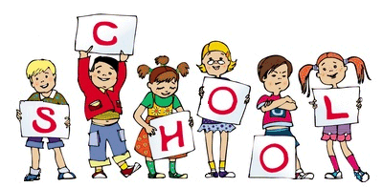

MCj04126840000[1]

MCj04126840000[1]

We have made some fantastic Poppy crosses in EYFS this week. The children used red tissue paper and black card to make their own poppy and then stick it onto a giant cross. They have been displayed in the classroom to help us remember the people who have been involved with war. ‘Miss Morris’ one of our students was a volunteer for the army and has supported in several wars. Today she gave such an inspirational speech to ALL of reception and shared some of her experiences. She brought in a medal from the queen and allowed the children to handle it. She also brought in a Christmas box, which was a present from the queen. Again she allowed the children to touch the contents, such as tea bags, torches, a card, a seasoning pot, and lots more very interesting items. A huge thank you to Miss Morris. During our ‘Remembrance Afternoon’ on Friday the children were also amazing. They sat in complete silence for 2 minutes and thought about the soldier who have died in the war! Well done RECEPTION!

Today our very little, but very sensible nursery children had a visit to Whitworth Art Gallery, Manchester. They were well behaved and enjoyed the activities. Most children enjoyed the drawing activity, where they had to lie down on the floor and draw around each other. Check out the website for groovy trip photos.

**Please** label **all** items of clothing, especially jumpers and coats. Thank you.

Notice Board/Dates for your Diary

TOPIC – **Senses**

**Dates for Diaries**

**Wed 15th Nov – School Photo** – Please wear full uniform and make your hair nice ☺

**Wed 16th Nov – Reception School Trip** – Please wear school uniform, bring a coat & bring a smile.

**Wed 17th Nov – Children in Need, non-uniform** – Please wear sensible clothes and shoes. Donation of £1.

Stars of the Week

Kourtney Corr

Safa Khalil

Safa Farhan

At Home

Ideas to help at home –

Practise Gross motor skills, e.g. using the climbing frame at a local park or riding on a bike or scooter, holding chalk or pens to draw on the ground/large paper.

Reception – This week’s homework is to use their senses at home and list the things they smell, taste, etc.

Encourage your child to practise writing their name.

Encourage children to listen for Initial sounds in words.

Number of the week: 9

General Reminders

* Nursery Parents Evening is a drop-in session, no need to book an appointment (21st&22nd Nov – 3:45-6pm)
* Reception Parents Evening is appointment only and must be booked with the correct teachers.
* Nursery children must have a bag of spare clothes and wet wipes on their peg (every day). Thank you.