Friday 24th November

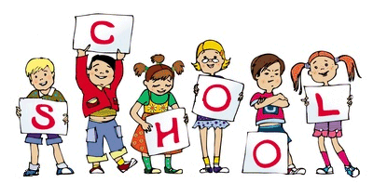

MCj04126840000[1]

MCj04126840000[1]

As you know this week we had an inspector from Ofsted come to visit our school. The children were complimented on their behavior and on their attitudes to learning. Thank you for the support you give to school and making sure that your children achieve their full potential.

In Literacy this week Nursery and Reception have been making AND EATING yummy fruit kebabs. They were really careful when using the pointy skewer to pierce the fruit and we all had lots of fun!

In topic the children have been using different senses, such as blindfold writing, using spice paint, decorating pictures with a range of textures, smelling and tasting clear water to guess the flavours.

Notice Board/Dates for your Diary

TOPIC – **Christmas**

**NATIVITY**

**Tuesday 5th December Reception** Nativity (Please arrive at school at 2:00pm for a 2:15pm start)

*If we finish before 3:15pm you will be able to take your children straight home.

**Wednesday 6th December Nursery** Christmas Sing a long (Please arrive at school at 2:15pm for a 2:30pm start)

We would like **ALL children** to bring a **Christmas/Festive themed jumpers** into school **by Friday 1st December** in a plastic bag with the **child’s name clearly labelled**.

Due to fire regulations unfortunately only **2 adults per child** will be allowed to watch the performance. Some of our super year 6 children will meet you at the community entrance to collect a £1 donation (per person) and show you into the hall.

At Home

Ideas to help at home –

Nursery – Ask your children to explain what they are drawing or writing.

Reception – This week’s homework is to use their senses at home and list the things they smell, taste, etc.

Number of the week: 4

Stars of the Week

Josiah Boma

Trystan Valley-Johnson

Thomas Hayes

General Reminders

* ALL children must have a bag of spare clothes and wet wipes on their peg (every day). This is essential so that we can help your child if they have an accident at school. Thank you for your cooperation.
* Thank you to all of the parents who attended parents evening this week.