Waste and Recycling Worksheet
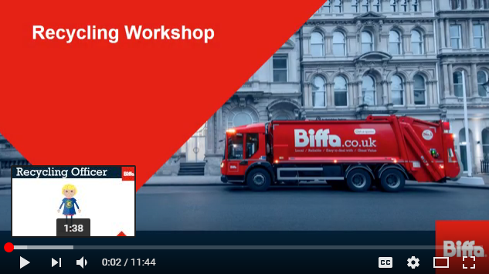
Watch the video by clicking on the link: https://www.youtube.com/watch?v=ush9oArExc4&t=11s

Video Questions
Who are Biffa and what do they do in Manchester?

What type of roles can you do for Biffa?

List 10 things that we put in the green recycling bin | List 10 things that we put in the blue recycling bin | List 10 things that we put in the brown recycling bin

Write 5 things that we put in the grey general waste bin

Why can’t we put soil and bricks in the bin?

What is the green bin recycling into?
What might happen if your recycling bin is contaminated?

Name the natural resource that the following products are made of
Glass | Plastic bottles | Paper | Food and drink cans

Why does it use a lot of energy to take natural resources from our earth?

Why are trees valuable to us?

What effects does global warming have across the world?

List 4 reasons why recycling is important for our planet
1.
2.
3.
4.

What can we make from recycled plastic bottles?

What can we make from recycled food and drink cans?

What can we make from recycled glass?

What can we make from recycled paper?

Fill the blanks!
Choose from the words on the next page to fill the blanks in the story.

The story of three plastic bottles

The story of three plastic bottles can help us to understand how throwing away our rubbish can affect our ___________.

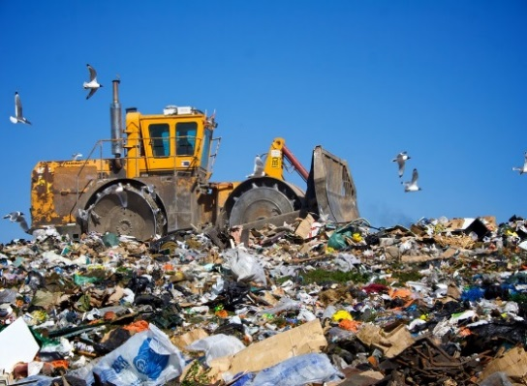
Once they have been drank, the three bottles are thrown on the ground as _________.

Bottle one, like millions of tons of others, is collected and ends up in ___________. This is a huge hole in the ground that is filled with rubbish.

Rubbish is pushed down from the weight of more rubbish. _________________ flows through the waste and can become toxic.

The toxic water can move into groundwater, soil and streams, poisoning ecosystems and harming ___________.

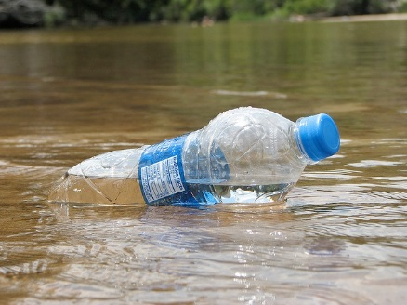
Bottle two’s journey is different, but no happier. The bottle floats into a stream, the stream into a river, then the river reaches the __________.

After months at sea, the bottle is slowly drawn into a massive whirlpool, where rubbish piles up into huge plastic islands.

The Great Pacific Garbage Patch is a huge collection of plastic in the Pacific Ocean. This is just one of many Garbage Patches in the world’s oceans.

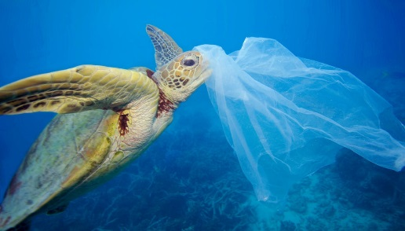
Plastic in the ocean can be very ______________ to sea animals.

Some animals can get entangled in the mess.

Some animals might mistake the plastic for ________ which could kill them.

Bottle three is collected by a ______________ truck and taken to the recycling centre.

At the recycling centre, the plastic bottle is separated and sorted into type, before being sent elsewhere to be turned into something _______.

Which bottle do you think had the best journey?

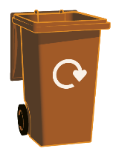
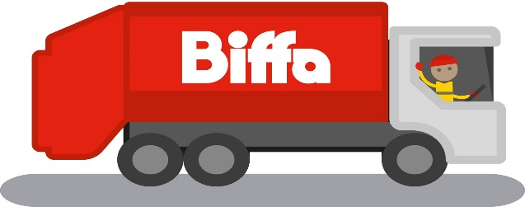
Recycling is really important because it saves our natural ____________ and wildlife, it reduces air and water __________, and it saves a lot of __________ and money.

Recycling is a way in which we can be _______________.

(Answers are upside down on the next page!)
sustainable | wildlife | recycling | landfill
pollution | dangerous | litter | food
Rain water | ocean | new | resources
energy | planet
1. Planet 2. Litter 3. Landfill 4. Rain water 5. Wildlife 6. Ocean 7. Dangerous 8. Food 9. Recycling 10. New 11. Resources 12. Pollution 13. Energy 14. Sustainable

Waste and Recycling Word Search

E L V E C U D E R H O X C L L C P P I Y
M S A E Y E C G I F G O H F O Y O L G X
Q C U N O A L X O B N Q H M O H H A B N
U K R E D Y T B R T L J P R U Z S S L S
Z J N H R F K C A M W O N O C N Y T C D
J Q G M G Q I M S N S C P E M W T I L Q
P L H P G D I L B T I A X B C O I C S Q
V P U Q A N B I L S C A I I V K R B L L
O J K E A C F X P Q O J T N Z E A O Y E
V A R T N N W A K Q R O E S G G H T R R
K B I T N E M N O R I V N E U M C T Y F
C O F T P P B E J M J P E Y U S R L P J
N X V C V W A E L Y K F S I X H E E L N
R Z S S Z M F P X R S W N Y X L C S M A
W E H O X M F F E O S I A O E P Y T W O
I P L Q W B H U L R M K G D L C C Q E N
N S C P G D I V A U S D D K P U L H N T
G R A S S C N J L A F H T Y P H E T J G
J W F H A Q D A P V E G H D A M W A N A
T H Y N A C M D U B V G L A S S J A R O
RECYCLE  ENVIRONMENT  APPLE  REDUCE  BREAD  CAN  ALUMINIUM  SUSTAINABLE  COMPOST | GLASS JAR  CONTAMINATION  GRASS  LANDFILL  PAPER  BOX  PLASTIC BOTTLE  REUSE  CHARITY SHOP  BIN

