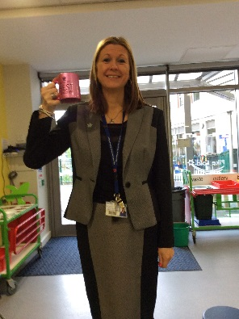[](http://www.google.co.uk/imgres?imgurl=http://www.expresssolicitors.co.uk/wp-content/uploads/2012/10/macmillan.jpg&imgrefurl=http://www.expresssolicitors.co.uk/community-spirit/staff-charitable-activities/macmillan-coffee-morning-raises-554&h=599&w=422&tbnid=H-X2-0VgxzxqQM:&zoom=1&docid=dHh4W9jrG07OhM&ei=er9IVNSkKuiM7Ab6yICQBw&tbm=isch&ved=0CHIQMygyMDI&iact=rc&uact=3&dur=1434&page=3&start=35&ndsp=20)

A very BIG thank you to all who supported our Macmillan Coffee Morning and cake sale. We raised £115, which is fantastic.

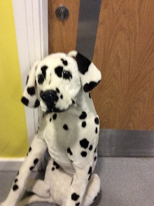

The winner of the dog was Ellis in Year 1 Pike.

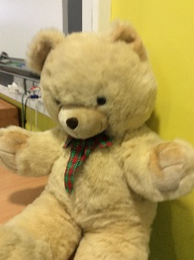

The winner of the teddy was Miss Wallwork

Here are a few photographs from the morning.

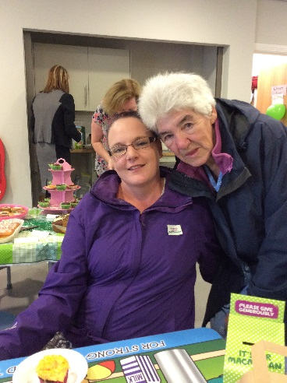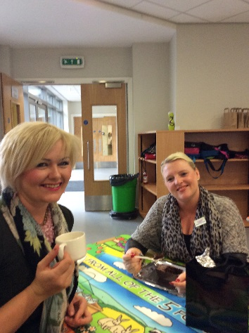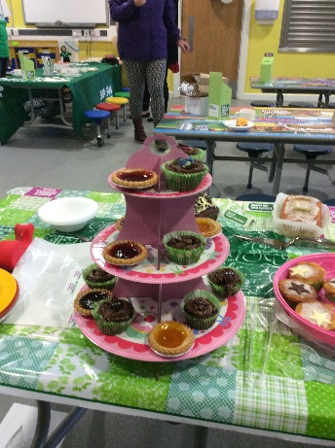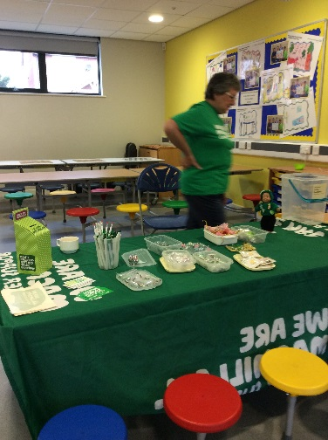

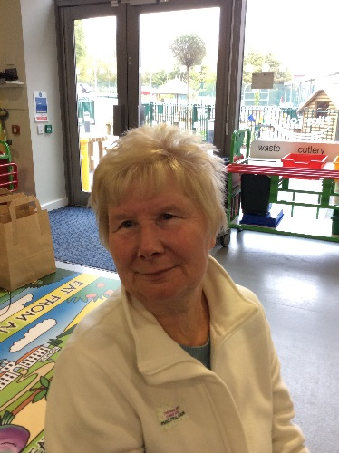

Once again thank you very much for all your support.

Mrs Robinson