Dear Parent/Carer,

Please find below examples of appropriate footwear for PE - Games. Trainers should be laced or have velcro straps and provide adequate foot/ankle support.
Fashion trainers are not appropriate i.e. Vans, Converse. Children are not allowed to take part in any PE- Games activity with this type of footwear as they are not designed for football, hockey etc.

The pupils do Gymnastics and Dance in bare feet.

Examples of Appropriate Footwear
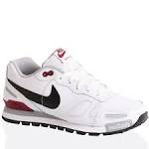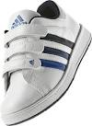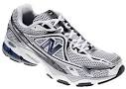

Unbranded, low cost trainers are ideal. A black pair is the preferred footwear.

Examples of Inappropriate Footwear
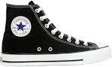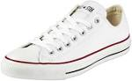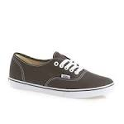
These are often made with synthetic materials with a thin sole, offering little protection or friction.

An extract from the school prospectus:
As we promote an active lifestyle and provide lots of physical activities we strongly advise all pupils to wear trainers, preferably black. If you feel it is necessary for your child to wear boots or wellies to walk to school in bad weather, please provide a change of indoor shoes/trainers.

Thank you for your continued support,

Mr Shevlin
P.E Coordinator

