Friday 27th November

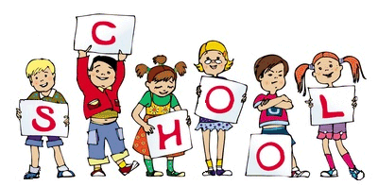

MCj04126840000[1]

MCj04126840000[1]

This week the children have been using their 5 senses to investigate lots of different fruits.

Nursery have been learning a number of the week – This week it has been number 2

Many of the Reception children will have lines to learn for the nativity and we would be grateful if you could help your child as much as possible. All the children are very excited to learn the songs and perform in front of their loved ones.

Reminder to bring in your Childs Nativity Costume as soon as possible and if you have any questions please speak to a member of staff.

Reception children need to practice taking shoes on and off in preparation for PE. Can we ask that children wear appropriate shoes i.e. Velcro, until they are able to tie their own shoe laces.

Notice Board/Dates for your Diary

TOPIC – **Senses**

Reminder – There is a coffee morning every Friday after Main school assembly in the dining room – Everyone Welcome

**Dates for Diaries –**

**Mon 7th Dec – Nursery Nativity** **2pm**

**Tue 8th Dec – Reception Nativity** **2pm**

**Wed 9th Dec – Christmas Dinner Day –** Christmas Jumpers to be worn

**Mon 14th Dec – EYFS Christmas Party day –** Party Clothes can be worn

**Fri 18th Dec – School Closes 2pm for Christmas Holidays**

Stars of the Week

This weeks Reception stars are:

**Miss Hawcroft – Addison**

**Miss Whittle – Maya**

**Mrs Hardy – Lola**

**Mrs Renshaw – Corben**

This weeks Nursery stars are:

**Mrs Armstrong & Mrs Singh – Sterling**

**Mrs Gyves & Miss Casey – Lily**

**Mrs Connell & Miss Armistead – Mason**[](http://www.google.co.uk/url?sa=i&rct=j&q=&esrc=s&source=images&cd=&cad=rja&uact=8&ved=0CAcQjRxqFQoTCMvglZ6A-scCFYxuFAodGpgExw&url=http://www.star-network.org.uk/index.php/news/comments/finished_those_finals_welcome_to_star_graduates/&psig=AFQjCNFc3KXkv2GomG9IIPHesW7q7Kvwlg&ust=1442439519771587)

At Home

Ideas to help at home –

Practise Gross motor skills, e.g. throwing and catching a ball, rainbow sticks – making and using outside.

Reception – This week’s homework is all about length and ordering different lengths from shortest to longest.

Encourage your child to practise writing their tricky words The, to, I, no, go

Encourage children to write their names.

General Reminders

* Please remember to bring in a waterproof coat and wellies (these can stay at school) everyday
* Please remember to write your child’s name in ALL their uniform as we are having lots of lost jumpers and cardigans but with no names in them.
* Nursery children are not allowed to stay in breakfast club without a parent/carer Thank you