Friday 11th December

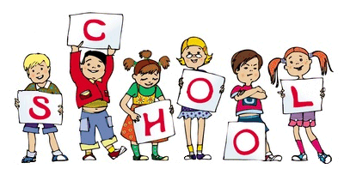

MCj04126840000[1]

MCj04126840000[1]

We want to start with a big thank you to everybody who attended the EYFS Nativity play this week. We hope you all enjoyed our version of The Nativity. We were very pleased with all the children who worked so hard to learn their lines and the songs. They all looked fantastic in their costumes and we are sure you are very proud as well. We will be continuing to sell raffle tickets for our Christmas Raffle on Monday. The raffle will be drawn on Wednesday 16th December at 2:45pm in the Dining room. Parents welcome please enter through Community entrance on Chapel Lane. The Nativity DVD will be £3 to purchase so please let a member of staff know if you would like to purchase one. Nursery have been learning a number of the week – This week it has been number 5

Notice Board/Dates for your Diary

TOPIC – **Senses**

Reminder – There is a coffee morning every Friday after Main school assembly in the dining room – Everyone is Welcome and Lee Burns (Parent Governor) will be available to talk to.

**Dates for Diaries –**

**Mon 14th Dec – EYFS Christmas Party day –** Party Clothes can be worn (Final Day for Key 103 Christmas Present drop off)

**Fri 18th Dec – School Closes 2pm for Christmas Holidays**

Stars of the Week

This weeks Reception stars are:

ALL children for a fantastic effort in the Nativity.

This weeks Nursery stars are:

ALL children for a fantastic effort in the Nativity.

[](http://www.google.co.uk/url?sa=i&rct=j&q=&esrc=s&source=images&cd=&cad=rja&uact=8&ved=0CAcQjRxqFQoTCMvglZ6A-scCFYxuFAodGpgExw&url=http://www.star-network.org.uk/index.php/news/comments/finished_those_finals_welcome_to_star_graduates/&psig=AFQjCNFc3KXkv2GomG9IIPHesW7q7Kvwlg&ust=1442439519771587)

At Home

Ideas to help at home –

Practise Gross motor skills, e.g. throwing and catching a ball, rainbow sticks – making and using outside.

Reception – This week’s homework is all about numbers and counting groups.

Encourage your child to practise writing their tricky words The, to, I, no, go

Encourage children to write their names.

General Reminders

* Please remember to bring in a waterproof coat and wellies (these can stay at school) everyday
* Please remember to write your child’s name in ALL their uniform as we are having lots of lost jumpers and cardigans but with no names in them.
* Nursery children are not allowed to stay in breakfast club without a parent/carer Thank you